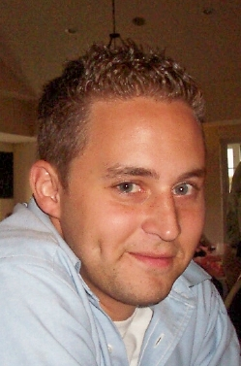
VICTIM: James (Jim) Bowerman

Sometime on April 11 or 12th, 2008, Jim Bowerman was murdered in his apartment on NE 130th Street and 15th Avenue.

Crime Stoppers is offering a $5,000 reward for information leading to the arrest and filing of criminal charges for the person responsible for this homicide. If you have any information regarding the person(s) involved, please contact Crime Stoppers anonymously at (305) 471-TIPS (8477).

For more information: www.justiceforjim.com

